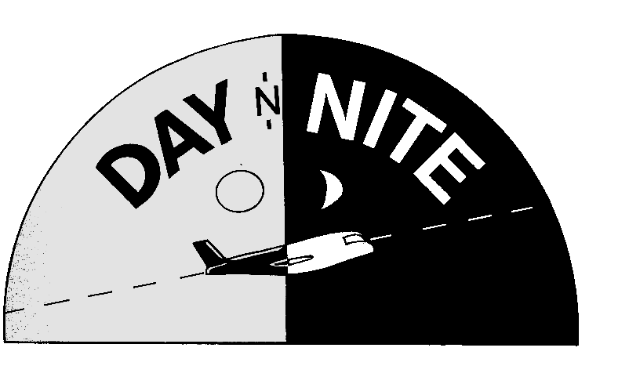
PO BOX 87333
CHICAGO ILLINOIS 60680
DAY N NITE INC P O BOX 87333 CHICAGO ILLINOIS 60680 312-663-1342

REFERENCE

NATIONAL FUTURE ASSOCIATION
300 SOUTH RIVERSIDE DRIVE
CHICAGO IL 60606
ATTN: CHARLES MANN
312-781-1438
CManns@nfa.futures.org

FOLEY AND LARDNER
321 NORTH CLARK ST
CHICAGO ILLINOIS 60601
ATTN: OSCAR MORINO
312-832-4322
dmanderson@foley.com

JOHNSON AND BELL
33 WEST MONROE ST
CHICAGO ILLINOIS 60602
ATTN: KEVIN CATCHING
312-984-6653
kenyonl@jbltd.com

URLAUB -BOWEN & ASSOCIATE
20 NORTH CLARK ST 1260
CHICAGO ILLINIOS 60602
ATTN:: WILLIAM HURON
312-781-9586
info@urlaubbowen.com

