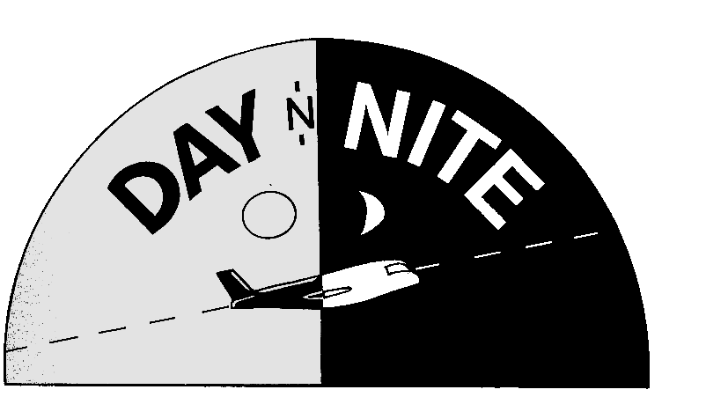
AIR & MESSENGER SERVICE
CHICAGO – LOOP
COURT FILING
0-10 POUND $5.50
EMERGENCY - ONE HOUR SERVICE
RETURN RECEIPT – $2.00
MAIL RUNS
RETURN RECEIPT – $2.00
MAIL PICKUP 540 N DEARBORN $16.50
MAIL DROP OFF MAIN POST OFFICE $22.00
CERTIFIED DROPOFF/RETURN RECEIPT $6.25

DISCOUNT SUBURBAN MESSENGER RATES AVAILABLE:

***ONLINE INTERNET SERVICES AVAILABLE***
CALL ALLEN DANDRIDGE
DAY-N-NITE SERVICES, INC.
228 SOUTH WABASH
SUITE 400
CHICAGO, ILLINOIS 60604
312 663-1342

A License & Bonded MBE Courier Co., Serving Chicago Since 1985.

